

Karachi School of

Business and Leadership

Department of Computer Science

“Memory Game”

Programming Fundamentals Lab (CS1101L)-Spring 2024

Submitted to **Sir Faisal Rafiq**

Submission date: 02/07/2024

“PROJECT MADE BY”

Umme Hani – B04-0923-000045

Shiza Khan – B04-0923-000028

Contents

Abstract: 3

Introduction: 3

Work: 4

Project Management: 4

Project Manual: 5

Project Results and Analysis: 6

Challenges Faced: 6





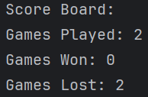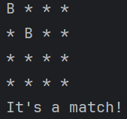

# 

# Abstract:

This Java program implements a memory game where players sign up or sign in to play. The game features a 4x4 board with hidden pairs of cards denoted by symbols. Players flip cards by entering coordinates, attempting to match pairs. If cards match, they remain revealed; otherwise, they are hidden again. Gameplay statistics such as games played, won, and lost are tracked for each user and stored persistently. User data is managed using file-based storage, allowing for retrieval and updating across sessions. The program provides interactive gameplay and user management functionalities through console input.

# Introduction:

The Memory Game project is a Java-based application designed as a fundamental programming exercise with elements of Object-Oriented Programming (OOP) principles. The project focuses on creating an interactive game where players can sign up, sign in, and play a memory game on a 4x4 board.

The game begins with a user authentication system where new users can sign up by providing a unique username and password. Existing users can sign in to access their profiles and game statistics. This functionality leverages file-based data storage to persist user information across sessions.

Once authenticated, players can start the memory game. The board consists of hidden pairs of cards represented by symbols ('A' to 'H'). Players flip cards by entering coordinates (row and column), aiming to match pairs. If cards match, they remain visible; otherwise, they are hidden again. The game tracks and displays statistics such as total games played, games won, and games lost for each player.

While primarily focused on procedural programming fundamentals, the project incorporates Object-Oriented Programming concepts. It includes the use of classes and objects to encapsulate user data (username, password, game statistics) and manage user interactions (sign-up, sign-in). Additionally, the separation of concerns into methods for board initialization, gameplay logic, user authentication, and data management reflects modular and reusable code practices.

The rest of the report is organized to provide a comprehensive understanding of the memory game project. The structure encompasses key sections aimed at detailing the various aspects of the project.

# Work:

In this project we’ve used Java and Object-oriented programming, promoting modularity, encapsulation, and code reusability through class definition, method abstraction, and data encapsulation. These principles contribute to efficient program design and maintenance, aligning with fundamental concepts of object-oriented software development.

# Project Management:

The development of Memory Game was a collaborative effort undertaken by a group of two people. It was effective and helped in successful execution of tasks. There was time management, division of certain responsibilities. Editing and writing code together at any given moment. Being contributive towards each other helped making this project before time.

# Project Manual:

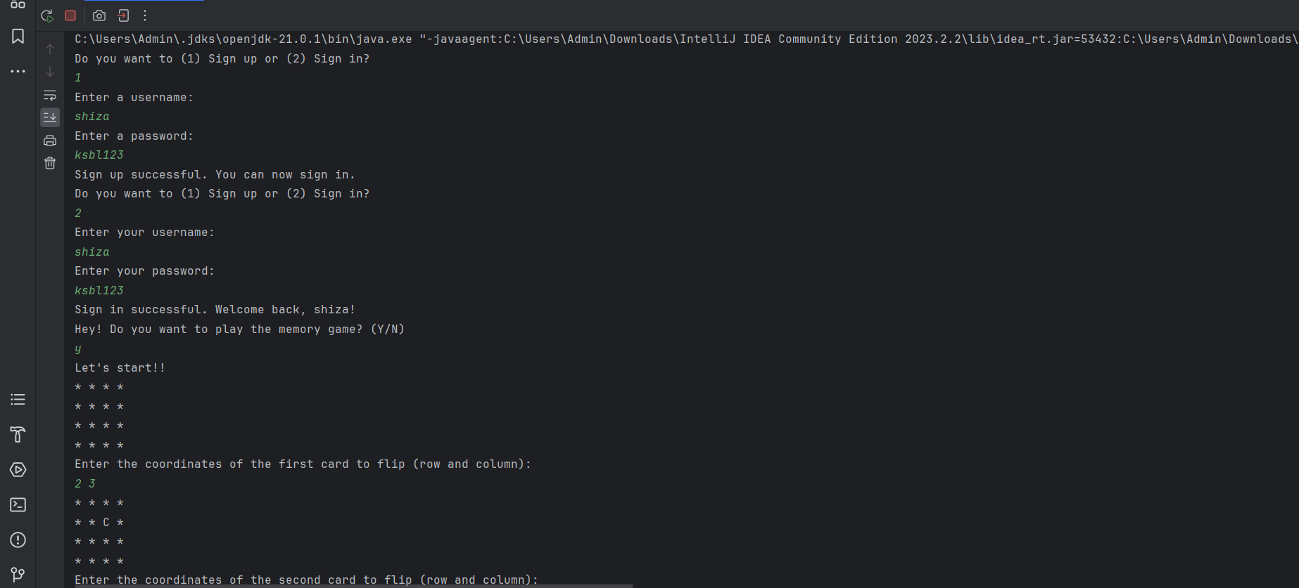

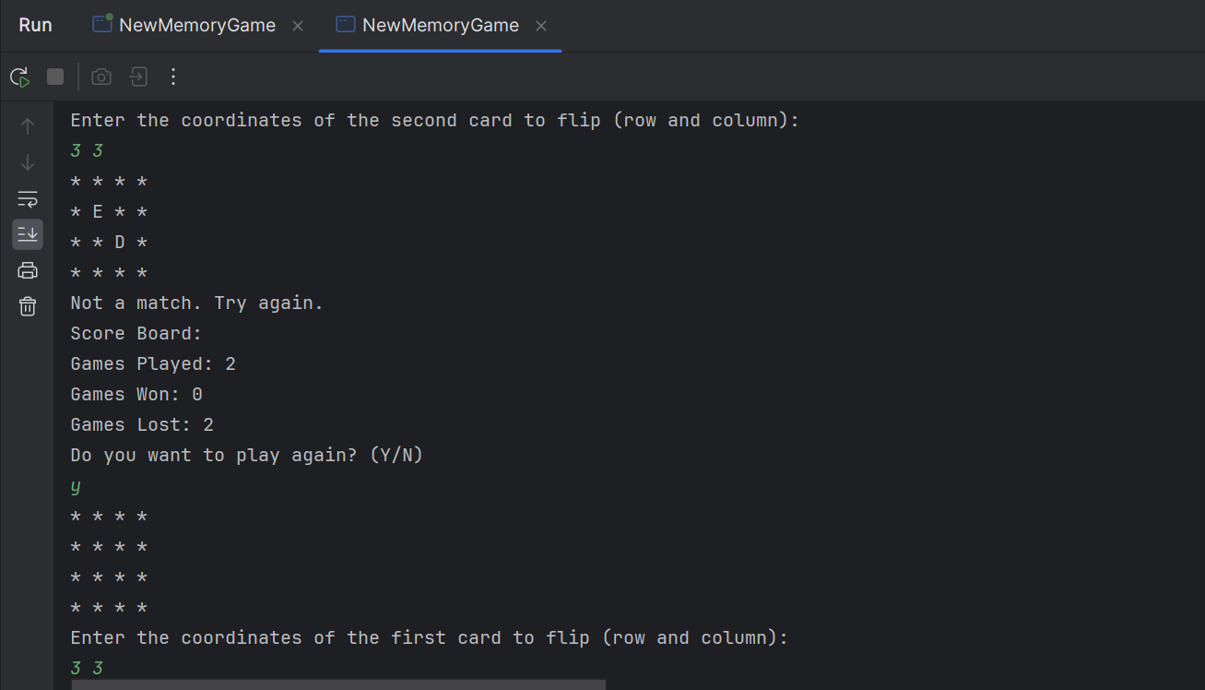

Here is an output manual of our project.

# 

# Project Results and Analysis:

Principle Results:

The Memory Game project in Java successfully applied Object-Oriented Programming (OOP) principles to create an interactive 4x4 board game. Key achievements include user authentication functionalities through signIn and signUp methods, ensuring secure user profile management with encapsulated data in the User class (username, password, game statistics). Interactive gameplay was achieved where players flip cards to match pairs ('A' to 'H'), with game statistics tracked (games played, won, lost) and stored persistently in users.txt using BufferedReader and BufferedWriter. The project exemplified modular design with methods like initializeBoard and displayBoard, promoting code reusability and maintainability.

Analysis:

Working with a partner is a great idea and not only it helps with timeline management, it makes half of your difficulties vanish away. Something that you are unable to understand, they might. Which makes things easier. There are some areas of improvement like risk management strategies, documentation quality etc.

# Challenges Faced:

The challenges that we faced particularly were of OOP, understanding the concepts that we have never studied and implementing them, it took a lot of time. Then the tasks that were given to us were continuously giving compile time error unless we implement more OOP concepts.